Instructions for the preparation of the full papers for dsm2022

First A. Author¹, Second B. Author¹, Third C. Author², Fourth D. Author², Fifth E. Author³

¹ Institution Name, Institution Address, Country, {First@university.com; Second@university.com}
² Institution Name, Institution Address, Country, {Third@university.com; Fourth@university.com}
³ Institution Name, Institution Address, Country, {Fifth@university.com}

Abstract
This document contains the necessary instructions for the preparation of a full paper for inclusion in the Proceedings of DSM2022 Conference – 2nd Portuguese Conference on Multibody Systems Dynamics, to be held in Guimarães, Portugal, on December 5 and 6, 2022. The abstract must not exceed 300 words. The article must not exceed 8 pages. Abstracts and articles can be written either in Portuguese or English.
These instructions and other information about the conference can be obtained by following the link https://dsm2022.tecnico.ulisboa.pt.
Introduction
The conference proceedings will be made available in digital format and will include the text and figures contained in the abstracts and full papers submitted by the authors. Abstracts and full papers must be submitted through the submission system available on the conference website, at https://dsm2022.tecnico.ulisboa.pt/submission. The submission of abstracts must be performed until October 14, 2022. The submission of full papers is optional and must be carried out until December 1, 2022.
At least one of the authors must register and pay the registration fee in order to ensure that their work is included in the conference proceedings.
GENERAL Requirements
The full paper must be written in Portuguese or English, divided into two vertical columns and centered on an A4 page. The full paper, including text, figures, tables, acknowledgments, references and eventual attachments, should not exceed a maximum of 8 pages. Articles that do not comply with this requirement will be forwarded to the respective authors for review.
styles
The Word file with instructions for preparing the full paper for DSM2022 provides a set of predefined styles (whose designation always starts with DSM2022 – Style name), with which it is possible to correctly format the entire document as well as automatically number all sections and subsections. To access these styles, authors should use the style bar.
Document Sections
Authors can use 5 different types of formatting styles for the titles of text sections: abstract section, main sections, secondary sections, secondary subsections, and other sections (acknowledgements and references). A pre-defined style is associated with each type of section mentioned. Main and secondary sections and secondary subsections should be numbered sequentially.
Main Sections
These sections are set automatically using the default style DSM2022 – Main section.
For manual formatting, the Main Sections should be written with Times New Roman font, size 11, in capital letters and in bold. Their alignment must be justified. A 12-point space must be left before the beginning of the section. These sections should be numbered sequentially.
Secondary Sections
These sections are set automatically using the default style DSM2022 – Subsection.
For manual formatting, the Secondary Sections should be written with Times New Roman font, size 11, with the first letter of each word in capital letters and in bold. Their alignment must be justified. A 12-point space must be left before the beginning of the section. These sections should be numbered sequentially.
Secondary Subsections
These sections are set automatically using the default style DSM2022 – Secondary Subsection.
For manual formatting, the Secondary Subsections should be written with Times New Roman font, size 11, with the first letter of each word in capital letters and in italic. Their alignment must be justified. A 12-point space must be left before the beginning of the section. These sections should be numbered sequentially.
Other Sections
The Abstract, Acknowledgments and References sections follow a similar format to the Main Sections, differing in the spacing before the beginning of the section and in not being numbered.
The predefined styles for these sections are:
- DSM2022 – ABSTRACT
- DSM2022 – OTHER SECTIONS
Text
Regular text should be written in black, with single space, justified alignment and in Times New Roman font, size 10. The first line should be indented 0.63 cm from the left margin. There is no spacing between paragraphs. This formatting can be automatically inserted in the text using the predefined style DSM2022 – Text.
Title, Authors and Affiliation
The first page must contain the title of the contribution, the authors names and their corresponding affiliation. Each of these requirements should be introduced in the appropriate places indicated in this document, and with the appropriate formatting.
Title
The title should be centered, immediately following the institutional heading of the conference. The font to be used must be Times New Roman, size 12 and in capital letters, with a spacing of 30 points with respect to the previous paragraph.
To proceed with an automatic formatting of the article title, it must be used the pre-defined style DSM2022 – TITLE.
Authors and Affiliation
The information about the authors and their institutional affiliation should be included according to the example provided in this file.
Authors
The authors designation must include, at least, the first name and the last surname. The names must appear sequentially and centered in Times New Roman font, size 10 and in bold. The use of the pre-defined style DSM2022 – Authors allows the automatic formatting of the authors' names.
Institutional Affiliation
The institution affiliation must be grouped and introduced after the authors’ list. It must be written in Times New Roman font, size 10. The use of the pre-defined style DSM2022 – Affiliation allows for the automatic formatting of the authors' affiliation.
Abstract
The abstract to be included in the full paper must contain a maximum of 200 words and as much as possible must be contained in the first column of the first page. The abstract follows the general rules of normal text insertion, and already specified in section 5 of this document, the only difference relies on the fact that it should appear in italic style. The default style for automatic abstract formatting is DSM2022 – Text Abstract.
Editorial Header
The Editorial Header must be included on the first page of the full paper, as indicated in this document and must not be altered by the authors.
On the remaining pages, authors should include their names in the headers according to the format indicated in 6.2 and at the top of this sheet.
Equations
Equations must be entered using specific software. They must be numbered sequentially according to the indicated format and must appear centered using tabs previously defined for this purpose in the style DSM2022 – Equations. Equations must be referred to in the text by this numbering. See as an example Eq. (1), written as follows:
(1)
A 6-point spacing should be left immediately before and after the paragraph containing the equation.
Figures
All figures must be numbered sequentially and captioned as indicated in Fig. 1. Figures must be referenced in the text prior to their insertion, as done in this paragraph.
Figures must be centered in the text column and their width must not exceed 8.5 cm. If it is necessary to introduce a figure with a width greater than 8.5 cm, a new section, with a single column, must be created.
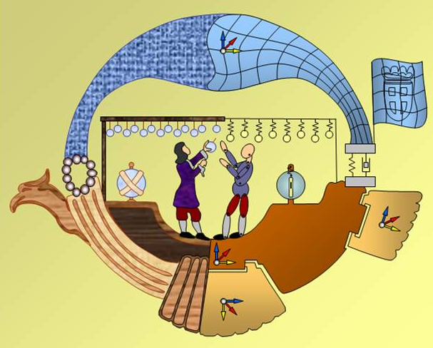
Figure 1. DSM2022 Logo – 2nd Portuguese Conference on Multibody Systems Dynamics.
The caption must be introduced using Times New Roman font, size 9. Their alignment must be justified. The paragraph must be indented left and right by 0.5 cm and the second line must be suspended 1.5 cm from the beginning of the paragraph. A tab stop at 2.0 cm and left justification should be introduced. A 6-point space must be kept for the previous paragraph and 12-point space for the following one. To automatically introduce the formatting described above, the default style to be used is DSM2022 – Caption Figure.
Tables
Tables must be numbered sequentially and referenced in the text, as in Table 1. Tables must appear centered.
Inserting the caption in the table follows the same rules described for inserting the caption in figures (see section 10). However, in this case, the caption must appear before the table, with a 12-point space for the previous paragraph and 6-point space for the following. The default style that allows to automatically introduce the formatting described above is DSM2022 – Caption Table.
Table 1. Topics for DSM2022 – 2nd Portuguese Conference on Multibody Systems Dynamics.
 | Conference Topics
1 | Biomechanics and medical applications
2 | Kinematics and synthesis of multibody systems
3 | Contact and impact
4 | Software development
5 | Dynamics of flexible multibody systems
6 | Vehicle dynamics and aerospace applications
7 | Education and educational applications
8 | Formulations and numerical methods
9 | Mechatronics, robotics and control
10 | Optimization and sensitivity analysis
11 | Coupled and interdisciplinary problems
12 | Real-time and parallel simulation
References insertion
References should be indicated in the text using appropriate numbering (e.g.: [1,2], [1-3]). The numbering should be organized in ascending order following the order in which the references appear in the text.
The informative content of the references should appear in the section REFERENCES in the end of the article. For the specifics of the required format, check the examples provided at the end of this document.
acknowledgments
The organizing committee thanks all authors for the care they took to use these instructions in the construction and formatting of their full papers for inclusion in the Proceedings of DSM2022.
References
[1] P. Nikravesh, Computer-aided analysis of mechanical systems. Prentice-Hall, New Jersey, 1988.
[2] W. Schiehlen, “Multibody systems dynamics: roots and perspectives”. Multibody Systems Dynamics, 1, 149-188, 1997.
[3] J. de Jalón, et. al., “Fast dynamc simulation of multibody systems”, J. Ambrósio edt. Multibody Dynamics 2003, ECCOMAS, 1-4 Julho, Lisboa, Portugal, 2003.

